**Project Two**

**SNHU**

* **Describe the required functionality of the project. Include the screenshots or screencast taken while testing and deploying your dashboard (Step 6) as proof that you have achieved the required functionality.**

For this project, we were tasked with creating an interactive dashboard for our client Grazioso Salvare for his rescue-animal training company. The dashboard is connected to the Mongo database, it then retrieves and displays data from the animal shelter database using the CRUD functionality.

The dashboard consists of four radio buttons that allow the user to filter through existing data and have it displayed on the interactive data table. The dashboard should also hold a geolocation map that displays markers for the location of each animal and a pie chart that shows the distribution of outcomes by rescue type.

Lastly, each item on the dashboard, the data table, the pie chart, and the map should all be updated based on the user’s filter selections. Below are screenshots of the dashboard based on the filter that the user selects.

The starting state of your dashboard

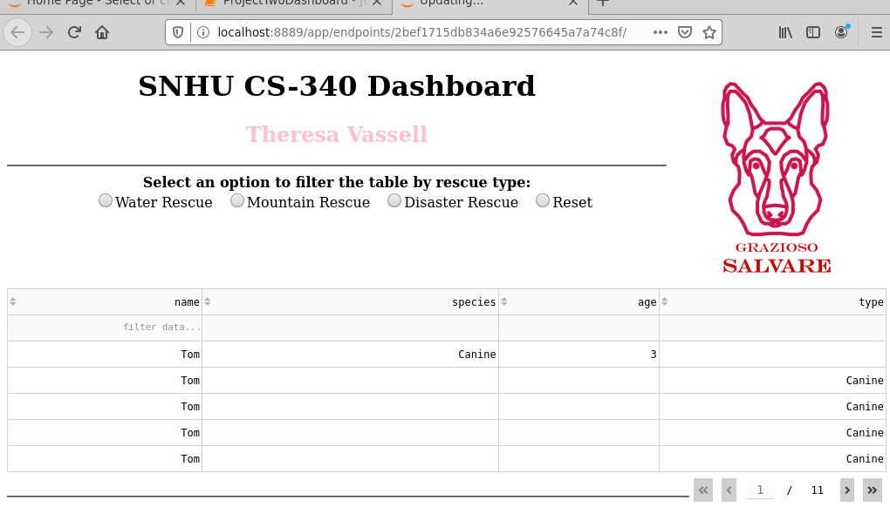

Water Rescue

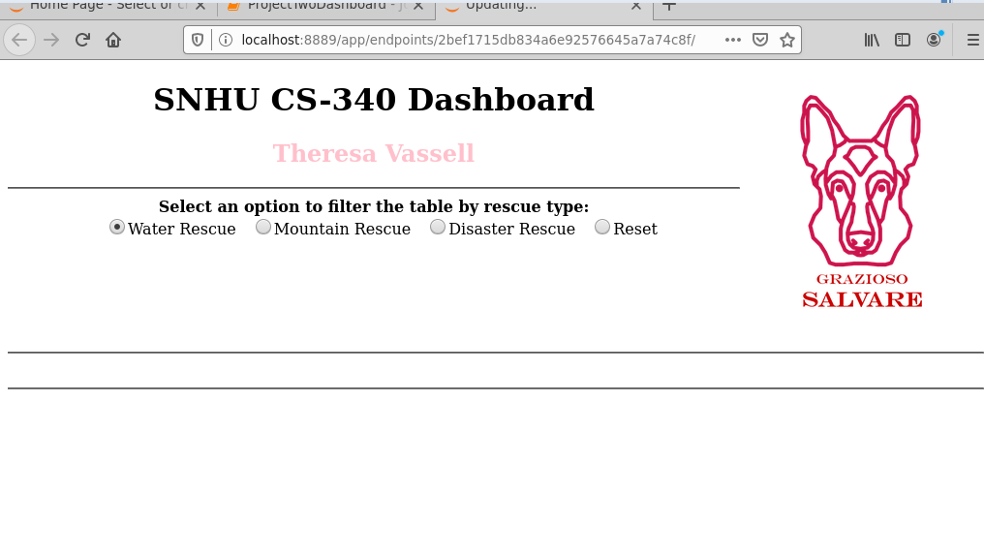

Mountain or Wilderness Rescue

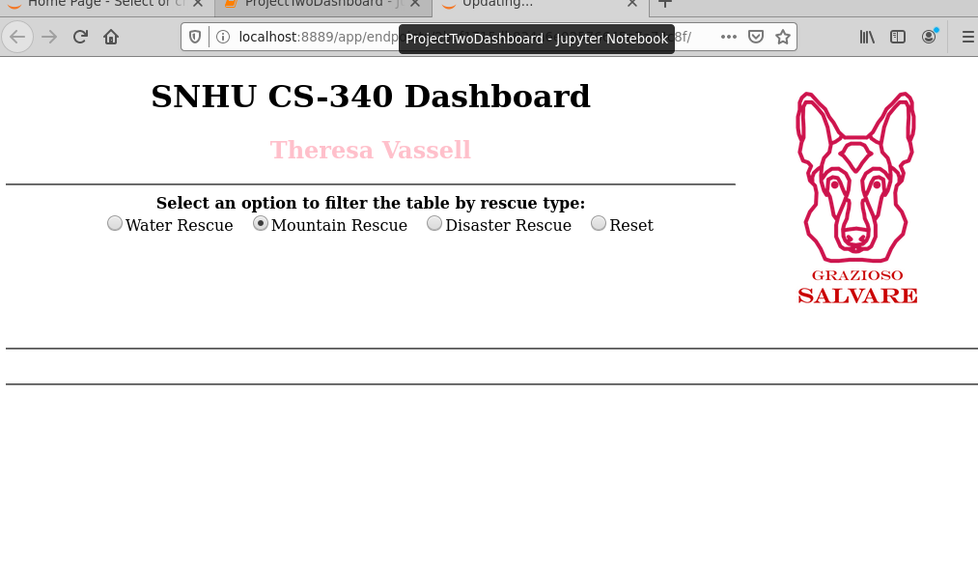

Disaster or Individual Tracking

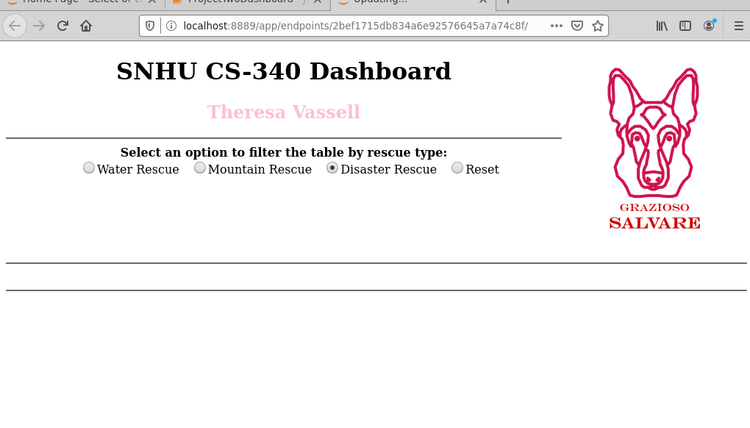

Reset

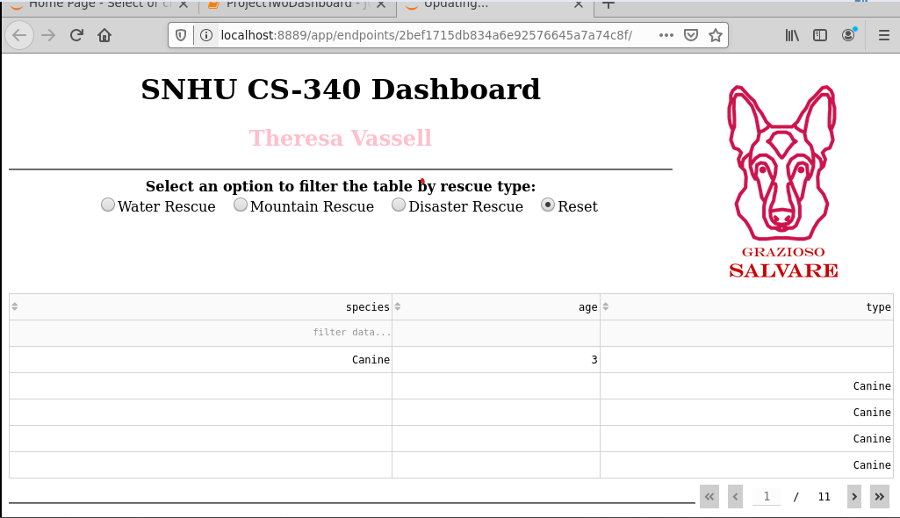

* **Describe the tools used to achieve this functionality and a rationale for why these tools were used.**
  + **Be sure to explain why MongoDB was used as the model component of the development, including what specific qualities or capabilities it provides for interfacing with Python.**

For this project, we utilized MongoDB as our database. MongoDB is a document database that is often used in cloud -computing and for creating internet applications. When completing this project MongoDB was used as the model component of the development because of its many different qualities and capabilities. For example, MongoDB is very cost-effective, it is easy to install, it requires no downtime for changing schemas, it allows for easy access to data and it is accessible from any language and placed in data structures native to that language. For example, dictionaries in Python.

* + **Be sure to explain the Dash framework that provides the view and controller structure for the web application.**

For this project, we utilized the Dash framework for providing the view and controller structure for the web application. Dash framework “is an open-source Python framework for building data visualization interfaces” (2023). The Dash framework makes the development of data-driven applications both simpler and faster. Its core is built on top of three main technologies Plotly.js, React, and Flask. The Dash framework can be especially useful when one is using Python to create a web application but isn’t very familiar with web development. Dash applications do not use HTML or JavaScript, only Python.

* + **Be sure to include links to any resources or software applications that were accessed or used.**

The following links played a huge role in helping with this project.

* + <https://learn.snhu.edu/content/enforced/1272217-CS-340-J7735-OL-TRAD-UG.23EW4/course_documents/CS%20340%20Dashboard%20Sample%20Walkthrough.pdf?_&d2lSessionVal=hYByOMoEPjTn52MngXPXJXlc5&ou=1272217>
  + <https://dash.plotly.com/dash-core-components>
  + https://dash.plotly.com/datatable
* **Explain the steps that were taken to complete the project.**

When completing this project these are the steps that were taken.

* Start the Mongo Shell
* Import the csv file aac_shelter_outvome.csv
* Create a simple and complex index to parse the data stored within the document.
* Create an “aacuser” account to access the database.
* Develop a Python module in a PY file to enable create, read, update, and delete (CRUD) functionality for the database.
* Create a Python script that imports the CRUD Python module so that it can call and test all instances of CRUD functionality
* Create a dashboard with an unfiltered view of the Austin Animal Center Outcomes data set using the Dash framework.
* Update the AAC dashboard with an interactive data table, a pie chart, and a geolocation map.
* **Identify any challenges that were encountered and explain how those challenges were overcome.**

This project was very challenging for me as I had a very hard time getting my pie chart and geolocation map to display on the dashboard. I contacted my professor and the IT help desk on this issue, however, I was unable to get it resolved.

**Citation**

* Real Python. (2023, March 17). *Develop data visualization interfaces in python with dash*. Real Python. Retrieved April 14, 2023, from https://realpython.com/python-dash/#:~:text=in%20this%20tutorial.-,What%20Is%20Dash%3F,requiring%20advanced%20web%20development%20knowledge.